**My Health and the SE model- Sleep deprivation**

A recent research has shown that Singaporeans sleep an average of 6 hours and 32 minutes in a day1, which is less than the recommended 7-8 hours of sleep for adults.2 Frequent short sleepers who sleep 4 hours or less per day often feel fatigued or are less motivated3 and have depressive moods which may lead to depression in the long run.4,5 Local reports have shown that up to 75% of youths in Singapore do not have enough sleep.6,7 Studies have shown that sleep deprivation in youths will increases the chance of developing mental health problems such as depression and low self-esteem8, which are lead to further social complications such as suicides.9 This shows that sleep deprivation among the young should not be neglected as it can potentially aggravates underlying social problems such as youth suicides and other mental health diseases.

Studies have shown that sleeping earlier will reduce the onset of depression and the likelihood of suicide, especially in adolescents.10 However, this is hindered by our fast-paced11 and competitive society12 which pushes youths into the mind-set that they need to be successful. Statistics shows that 83% of Singapore youths felt that they are expected to do their best as well as have to try to make their family members proud through achievements.13 Pressure to excel academically, especially nearing major examinations can lead to lesser sleeping hours as students may choose to prioritise their revision over sleep14 in order to ensure that they memorise enough content or have done enough practices.

This can be worsen when youths cannot go to bed early due to overwhelming workloads or homework15 that they have to complete, or simply because they return home late from their activities, such as tuition16 and Co-Curricular Activities (CCA).17 Students often have to stay up late into the night to finish piling homework as well as to study for any tests. Survey done among Junior College students show that 97% felt sleepy during their classes18, showing that they do not obtain enough sleep on week days. Students can also feel irritated due to their slow response time or unable to focus on their classes or assignments in school. The loss of concentration due to insufficient sleep can lead to a vicious cycle as they have to put in extra hours at home to catch up when they cannot concentrate in class.

Meritocratic system in Singapore do not help ease this problem of sleep deprivation in youths, as the government recognises individuals who excel academically more than those who do not19. Parents determined to ensure that their children excel in school and exams for a better future often enrol them into tuition classes so that they can get ahead of their peers. 20,21 When the children have difficulty acing their examinations, the family may push children to go for more tuition or enrichment classes. This creates more internal pressure in the individual student to put in more time so as to ensure that they can be able to live up to the expectations of their peers, school and the family. In addition, parents may push their children to complete additional assessment books and exercises or their tuition homework, pushing back their sleep times.

In addition, the local education system encourage students to excel in their CCA besides their academic studies.22 It is compulsory to join a CCA at the secondary school level23, and CCA achievements in tertiary schools is considered for distinguished scholarships or discretionary admission to local universities.24 Schools may push students to put in additional hours for their niche CCAs as MOE recognises schools with their niche strengths.25 This adds onto the typical 40-hour work-week that students have to spend on compulsory lessons26, not factoring any amount of travelling time on public transport. A study done revealed that Secondary and Tertiary Schools students who commuted by public transport took about 40 - 50 minutes on average.27 Thus, it is likely that a typical student spends 8-12 hours in school or on the way to school. This leaves youths with very little time to catch up on their school work such as conduct revisions or complete assignments at home or even pursue their personal interests without sacrificing their sleep time.

Fortunately, there is a general understanding that too much homework and school work is a pressing social problem and is gradually addressed through various means. The implementation of “Teach Less, Learn More” policy in Primary Schools has led to reduced teaching content by between 10 to 20 percent since 2005.28 The Ministry of Education (MOE) has also stopped announcing top scorers in order to reduce the overemphasis of excelling at national examinations.29 Our Prime Minister, Mr Lee Hsien Long spoke against the overemphasis of getting children ahead of their peers in the 2012 National Rally Speech.30

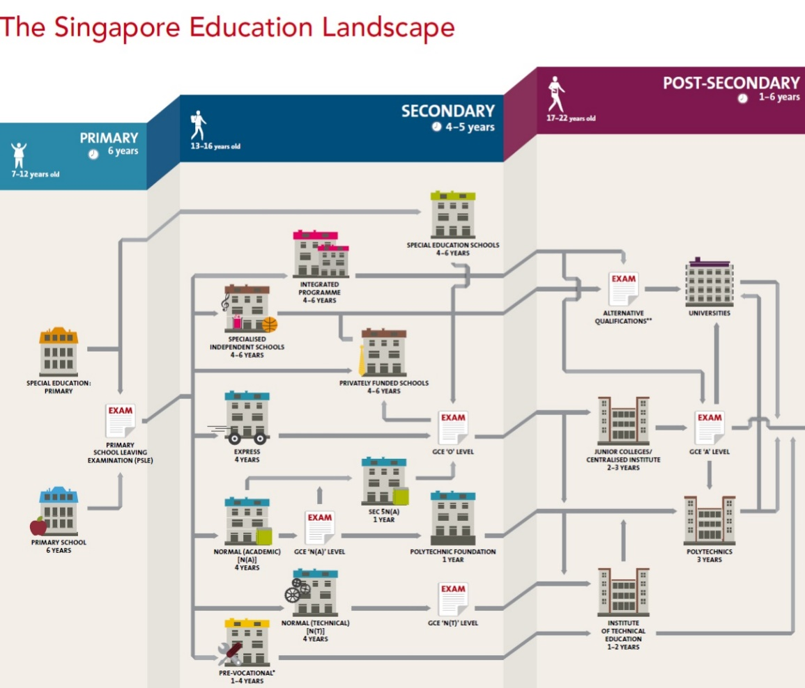

Figure 1: Singapore’s Education System[1]

However, as there is still an emphasis on results of national examinations due to it determining the course and choices for higher education (as seen in figure 1), the likelihood of youths being sleep deprived remains high as they have to do “exam learning” in schools31 as well as dedicate majority of their time towards studying and understanding their syllabus in ensuring that they will be able to do well in their examinations.

Being a student under this system, it has always seemed to me that the only way to good grades at national exams is through repeated practice to hone examination skills, and to ensure that content is mastered at the back of our fingertips so as to be able to write them out under examination conditions which often involves rushing through the paper. Thus, it is not uncommon to do practice papers for every major school examinations such as the mid-terms or the end of year papers. Schools often go through all of them in a rushed manner during the last two weeks before the examinations, which often forces us to be able to cope with revision and doing practice papers at the same time during this period. Those who prefer to revise and practice separately will require more time which only have to be “squeezed” out through sacrificing sleep. For students with impending national examinations, it is not uncommon for schools to practice “hell” year, which students have to face weekly topical revision tests for each subject and master the remaining of the syllabus quickly so as to ensure that there is a 2-3 months window for repeated paper practices. This puts me and my peers under huge pressure to keep up and we often do not have enough sleep as teachers may give us last minute assignments or tests.

While it has also been suggested that Singapore should try adopt a “direct primary-to-secondary-education model” so as to remove the need for examinations and academic performance32, parents may not enrol their children into such schools due problems seen in a similar program known as the Integrated Programme (IP). Implemented in some secondary school, the Integrated Programme (IP) aims to help the students ease examination pressures by allowing students to proceed onto Junior Colleges without taking the GCE ‘O’ Level Examinations.33 However, there are people who find it hard to cope under the IP system and drop-out of the system,34 reflecting that there is still pressure on the students to perform. The students also may perform badly at the GCE ‘A’ Level due to the lack of practice for examination skills and thus are unable to get into prestigious universities.35 With such stories circulating on various forums, social media platforms and local papers, it is also likely increase the anxiety of “kiasu” parents to monitor their kids’ progress on such systems. Thus, there is a need for a various number of policies in order to address such a social attitude towards examinations and education in addition to reducing the number of examinations.

In conclusion, sleep deprivation has developed to be a common yet often overlooked problem among Singapore youths. While it seems inevitable that youths have to sacrifice part of their sleep in order to maintain their academic results, current policies has been working towards creating a more stress-free environment to decrease the likelihood of the need to sacrifice sleep over school work. More efforts is required by the society to ensure that youths have sufficient sleep to support growth and development.36 Suggested policies can include incorporation of nap-time into the school timetable which is adopted by the Taiwan education system to refresh students’ mind.37 Another viable option for larger schools can be the implementation of “Napping Stations”38 for students to take a short nap between their classes or before the start of their CCAs. Thus, the government need to put in more long term efforts to influence and alter the mind-set of the community as social attitudes is mainly responsible for the both the individual level factors and other environmental factors that leads to the support of such a condition for sleep deprivation of youths to occur.

**References**

1. Singapore among cities in the world with least hours of sleep: Study. Available at: http://www.straitstimes.com/news/singapore/health/story/singapore-among-cities-the-world-least-hours-sleep-20140820. Accessed September 1, 2014.

2. How Much Sleep Is Enough? - NHLBI, NIH. Available at: http://www.nhlbi.nih.gov/health/health-topics/topics/sdd/howmuch.html. Accessed September 12, 2014.

3. Browne BJ, Van Susteren T, Onsager DR, Simpson D, Salaymeh B, Condon RE. Influence of sleep deprivation on learning among surgical house staff and medical students. *Surgery*. 1994;115(5):604-10. Available at: http://europepmc.org/abstract/med/8178259. Accessed September 4, 2014.

4. Fredriksen K, Rhodes J, Reddy R, Way N. Sleepless in Chicago: tracking the effects of adolescent sleep loss during the middle school years. *Child Dev*. 2004;75(1):84-95. Available at: http://www.ncbi.nlm.nih.gov/pubmed/15015676.

5. Pasch KE, Laska MN, Lytle LA, Moe SG. Adolescent sleep, risk behaviors, and depressive symptoms: are they linked? *Am J Health Behav*. 34(2):237-48. Available at: http://www.pubmedcentral.nih.gov/articlerender.fcgi?artid=3086400&tool=pmcentrez&rendertype=abstract. Accessed September 1, 2014.

6. 4 in 5 teens not getting enough sleep (The Straits Times, Mon, pg B2) – Singapore General Hospital. Available at: http://www.sgh.com.sg/about-us/newsroom/News-Articles-Reports/2009/Pages/4-in-5-teens-not-getting-enough-sleep-The-Straits-Times,-Mon,-pg-B2--20090105.aspx. Accessed September 1, 2014.

7. Not enough sleep? Kids in Singapore sleep less than those in Switzerland: Study . Available at: http://www.straitstimes.com/news/singapore/health/story/not-enough-sleep-20120420. Accessed September 1, 2014.

8. Roberts RE, Roberts CR, Duong HT. Sleepless in adolescence: prospective data on sleep deprivation, health and functioning. *J Adolesc*. 2009;32(5):1045-57. doi:10.1016/j.adolescence.2009.03.007.

9. Reinherz HZ, Giaconia RM, Hauf AM, Wasserman MS, Silverman AB. Major depression in the transition to adulthood: risks and impairments. *J Abnorm Psychol*. 1999;108(3):500-510. doi:10.1037/0021-843X.108.3.500.

10. Gangwisch JE, Babiss LA, Malaspina D, Turner JB, Zammit GK, Posner K. Earlier parental set bedtimes as a protective factor against depression and suicidal ideation. *Sleep*. 2010;33(1):97-106. Available at: http://www.pubmedcentral.nih.gov/articlerender.fcgi?artid=2802254&tool=pmcentrez&rendertype=abstract. Accessed September 1, 2014.

11. Pace of life speeds up as study reveals we’re walking faster than ever | Mail Online. Available at: http://www.dailymail.co.uk/sciencetech/article-452046/Pace-life-speeds-study-reveals-walking-faster-ever.html. Accessed September 1, 2014.

12. More young professionals suffering from burn-out. Available at: http://www.straitstimes.com/news/singapore/health/story/more-young-professionals-suffering-burn-out-20140414. Accessed August 23, 2014.

13. Council NY. Youth Statistics In Brief. 2013. Available at: https://www.resourceportal.nyc.sg/nycp/ShowDoc/WLP Repository/nyc/resources_fs/Youth Stats in Brief 2013.

14. Gau SF, Soong WT. Sleep problems of junior high school students in Taipei. *Sleep*. 1995;18(8):667-73. Available at: http://www.ncbi.nlm.nih.gov/pubmed/8560133. Accessed September 1, 2014.

15. Cut some slack, give homework a rest.http://www.straitstimes.com/the-big-story/case-you-missed-it/story/cut-some-slack-give-homework-rest-20130806. Accessed August 23, 2014.

16. MPs call for closer look at private tuition industry | TODAYonline. Available at: http://www.todayonline.com/singapore/mps-call-closer-look-private-tuition-industry-0. Accessed September 1, 2014.

17. Are students spending too much time on CCAs? Available at: http://www.straitstimes.com/breaking-news/singapore/story/are-students-spending-too-much-time-ccas-20140331. Accessed August 23, 2014.

18. Get more sleep, Singapore | What’s buzzing? - Yahoo News Singapore. Available at: https://sg.news.yahoo.com/blogs/what-is-buzzing/more-sleep-singapore-20110317-043354-518.html. Accessed September 6, 2014.

19. Status S, Analysis S. Singapore Education Sector Analysis : Improvement and Challenges in Academic Performance of Four Ethnic Groups in Singapore. 2002.

20. National Volunteer & Philanthropy Centre. Singapore social health project 2013. 2013.

21. Blackbox Research Pte Ltd. Private Tuition in Singapore. 2012. Available at: http://www.blackbox.com.sg/wp/wp-content/uploads/2012/09/Blackbox-You-Know-Anot-Whitepaper-Private-Tuition.pdf.

22. MOE revises framework for recognising CCA achievements | TODAYonline. Available at: http://www.todayonline.com/singapore/moe-revises-framework-recognising-cca-achievements. Accessed September 4, 2014.

23. Ministry of Education, Singapore: Education System: Secondary Education: Co-Curricular Activities (CCAs). Available at: http://www.moe.gov.sg/education/secondary/cca/. Accessed September 6, 2014.

24. Ministry of Education, Singapore: Parliamentary Replies - Discretionary Admission Scheme. Available at: http://www.moe.gov.sg/media/parliamentary-replies/2014/02/discretionary-admission-scheme.php. Accessed September 12, 2014.

25. Ng PT. Quality assurance in the Singapore education system in an era of diversity and innovation. *Educ Res Policy Pract*. 2007;6(3):235-247. doi:10.1007/s10671-007-9018-x.

26. UNESCO-IBE. *Singapore*.; 2007. Available at: http://www.ibe.unesco.org/fileadmin/user_upload/archive/Countries/WDE/2006/ASIA_and_the_PACIFIC/Singapore/Singapore.pdf.

27. Department of Statistics Singapore. *Usual Mode of Transport to Work*.; 2005:3-12.

28. Teach Less, Learn More - Have We Achieved It? | Media Coverage | Newsroom | National Institute of Education (NIE), Singapore. Available at: http://www.nie.edu.sg/newsroom/media-coverage/2012/teach-less-learn-more-have-we-achieved-it. Accessed September 1, 2014.

29. MOE, SEAB to stop listing top—scoring students in all national exams - xinmsn News. Available at: http://news.xin.msn.com/en/storyviewer-commented.aspx?cp-documentid=251179136. Accessed September 4, 2014.

30. Prime Minister Lee Hsien Loong’s National Day Rally 2012 (Speech in English). Available at: http://www.pmo.gov.sg/content/pmosite/mediacentre/speechesninterviews/primeminister/2012/August/prime_minister_leehsienloongsnationaldayrally2012speechinenglish.html#.VAiEB_mSxTo. Accessed September 4, 2014.

31. Why is Singapore’s school system so successful, and is it a model for the West? | Media Coverage | Newsroom | National Institute of Education (NIE), Singapore. Available at: http://www.nie.edu.sg/newsroom/media-coverage/2014/why-singapores-school-system-so-successful-and-it-a-model-west. Accessed September 4, 2014.

32. MP proposes piloting cluster of schools without exams, streaming | TODAYonline. Available at: http://www.todayonline.com/singapore/mp-proposes-piloting-cluster-schools-without-exams-streaming. Accessed September 9, 2014.

33. Ministry of Education, Singapore: Education System: Secondary Education: Other Programmes: Integrated Programme (IP). Available at: http://www.moe.gov.sg/education/secondary/other/integrated-programme/. Accessed September 9, 2014.

34. Six per cent of Integrated Programme students in 2008 cohort dropped out. Available at: http://www.straitstimes.com/breaking-news/singapore/story/six-cent-integrated-programme-students-2008-cohort-dropped-out-2014012. Accessed September 9, 2014.

35. Davie S. Some students fail to thrive on Integrated Programme scheme. *SPH*. December 22, 2011.

36. Why Is Sleep Important? - NHLBI, NIH. Available at: http://www.nhlbi.nih.gov/health/health-topics/topics/sdd/why.html. Accessed September 6, 2014.

37. *Going to School in East Asia*. Greenwood Publishing Group; 2007:483. Available at: http://books.google.com/books?id=HuE--CIdDuEC&pgis=1. Accessed September 4, 2014.

38. Napping Around: Colleges Provide Campus Snooze Rooms | TIME. Available at: http://time.com/3211964/nap-rooms-at-universities/. Accessed September 4, 2014.

39. Ministry of Education. EDUCATION IN SINGAPORE. *Minist Educ*. Available at: http://www.moe.gov.sg/about/files/moe-corporate-brochure.pdf. Accessed September 4, 2014.

1. Diagram obtained from Ministry of Education (MOE) brochure39, page 13. Image is cropped to remove irrelevant material.